Employee Data Analysis Report

A Data-Driven Look at Employee Structure and Engagement

**Prepared for: Prepared by:**

estarta Data Team Aya Eqailan

September 13, 2025

Contents

1. Introduction 3

2. Methodology 3

3. Analysis and Findings 4

3.1 Compensation & Rewards 4

3.2 Workforce Diversity 6

3.3 Employee Retention & Employment Status 8

3.4 Employee Demographics & Tenure 9

4. Conclusion 10

Figure 1: Annual Salary Summary (All Employees) 4

Figure 2: Annual Salary Distribution by Department 5

Figure 3: Bonus Distribution by Department 5

Figure 4: Ethnicity Distribution by Department 6

Figure 5: Male to Female Ratio in Company 6

Figure 6: Male vs Female Distribution by Department 7

Figure 7: Still Employed Employees by Department 8

Figure 8: Still Employed Employees by Ethnicity 8

Figure 9: Age Distribution of Employees 9

Figure 10: Tenure Distribution(Years) 9

Figure 11: Number of Employees by Country 10

# Introduction

This report presents an analysis of employee data within the company, with the objective of uncovering insights that can support decision-making and improve organizational performance. The process included cleaning and preparing the raw data, exploring key patterns and trends, and visualizing the results for clearer interpretation. By understanding the data more deeply, this analysis addresses potential challenges and guides future strategies.

# Methodology

The employee dataset provided was analyzed using Python in Google Colab. 0Libraries, including Pandas, Matplotlib, and Seaborn, were applied to clean, process, and visualize the data. The analysis process included:

* Data Cleaning: handling missing values, correcting inconsistencies, and preparing the dataset for accurate analysis.
* Exploratory Data Analysis: examining key patterns, distributions, and relationships within the data.
* Data Visualization: creating clear and interpretable charts to highlight trends and insights.

# Analysis and Findings

## Compensation & Rewards

Figure 1: Annual Salary Summary (All Employees)

The figure shows that annual salaries range from a minimum of **$20,000** to a maximum of **$258,498**, with a median salary of **$96,475**. This indicates a wide pay range across the company, with a midpoint close to $100K.

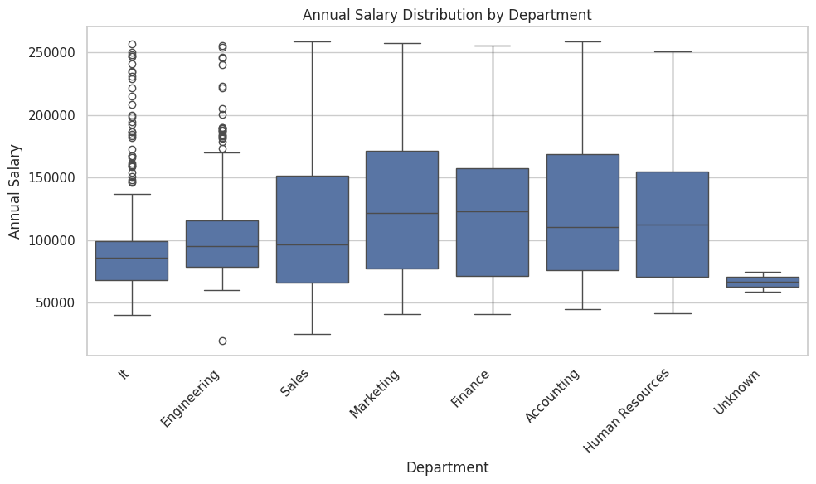

Figure 2: Annual Salary Distribution by Department

Figure 2 shows that salary ranges vary significantly across departments. In IT and Engineering, most people earn fairly similar salaries, while in other departments, salaries vary much more widely.

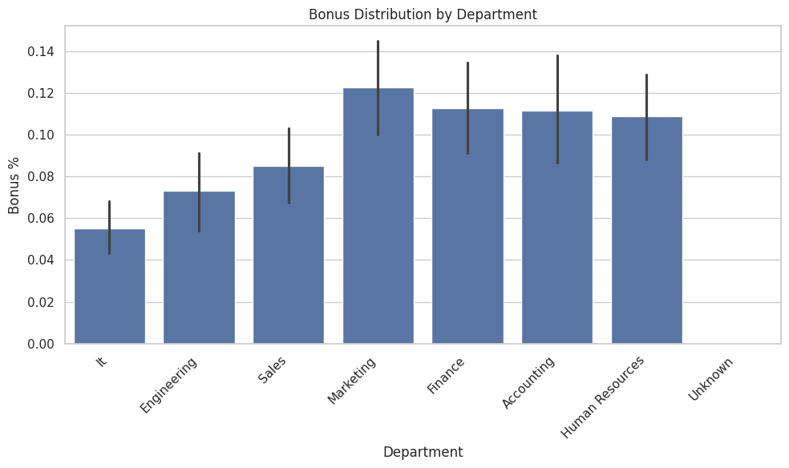

Figure 3: Bonus Distribution by Department

Figure 3 highlights that bonus percentages are not evenly distributed across departments. Marketing, Finance, HR, and Accounting receive the highest average bonuses (above 10%), while IT and Engineering report the lowest bonus rates.

## Workforce Diversity

Figure 4: Ethnicity Distribution by Department

Figure 4 shows that employees of Asian ethnicity are the largest represented group across most departments, while Black employees are the least represented. This indicates an uneven distribution of ethnic diversity within the company’s workforce.

Figure 5: Male to Female Ratio in Company

At the company-wide level, the male-to-female ratio is nearly equal, suggesting there is no overall gender imbalance in the workforce.

Figure 6: Male vs Female Distribution by Department

The distribution of male and female employees appears balanced across all departments, with no significant gender dominance observed. This reflects a strong level of gender representation at the departmental level.

## Employee Retention & Employment Status

Figure 7: Still Employed Employees by Department

The majority of employees remain actively employed across all departments, with only a small proportion no longer with the company.

Figure 8: Still Employed Employees by Ethnicity

Retention appears consistent across ethnic groups, with most employees still employed regardless of ethnicity.

## Employee Demographics & Tenure

Figure 9: Age Distribution of Employees

The age distribution shows that most employees fall between **40 and 50 years old**, making this the largest age group in the company

Figure 10: Tenure Distribution(Years)

Figure 11: Number of Employees by Country

# Conclusion

The analysis of employee data reveals several key insights regarding workforce composition and retention:

**Gender Balance:** There is no significant bias between genders across the company; male and female employees are nearly equally represented in all departments.

**Retention:** The proportion of still-employed employees is very high across all departments, indicating strong overall retention.

**Ethnicity Distribution:** Asian employees constitute the largest group in most departments, whereas Black employees are less represented. This highlights potential areas to focus on for diversity and inclusion initiatives.

**Bonus:** There is an imbalance in bonus distribution, with IT and Engineering receiving the least compared to other departments.

Overall, the workforce demonstrates strong retention and gender balance, while the analysis of ethnicity distribution points to opportunities for enhancing diversity.